Lec 13
P.13
Synthetic Skin Grafts - Integra
1. Integra Overview
- Integra: A bilayered dermal substitute (雙層真皮替代物) developed by Integra Life Sciences Corp. in Plainsboro, NJ.
- Primary Use: Commonly used for coverage of excised acute burns (切除急性燒傷後的覆蓋物).
2. Development Background
- Developed by Drs. Burke and Yannas at MIT during the 1980s.
- Designed for full-thickness skin defects (全厚皮膚缺損).
3. Composition
- Inner Layer (靠近傷口的一側):
- Made of a crosslinked bovine collagen matrix (交聯牛膠原基質) and chondroitin-6-sulfate (硫酸軟骨素-6).
- Acts as a dermal regeneration template (真皮再生模板), promoting neodermis (新生真皮) formation.
- Outer Layer (外層):
- Made of silicone (矽膠).
- Functions as an epidermal barrier (表皮屏障) to:
- Prevent heat and water loss.
- Block bacterial entry.
- Maintain protection until the neodermis develops enough to accept ultrathin epidermal autologous grafts (超薄自體表皮移植物).

4. Bilaminate Structure
- The bilaminate structure (雙層結構) is a common design for commercially available skin replacement devices.
- It can be used as either temporary (暫時性) or permanent (永久性) skin replacement.
P. 20
Skin Bio-Printing
1. Concept Overview
- 3D Bio-Printing (三維生物列印):
- A proof-of-concept (概念驗證) study to engineer human skin through a layer-by-layer assembly (逐層組裝) process involving fibroblasts (成纖維細胞) and keratinocytes (角質細胞).

2. Features of 3D Bio-Printing
- Precise positioning (定位) of multiple types of matrix materials (基質材料) and cells.
- Capability to construct functional tissues of various sizes with appropriate structures (結構) and cell compositions (細胞組成).
- Offers hierarchical control (分層控制), high throughput (高通量), and a tailored (可定製且具可重現性) approach.

3. Advantages
- Demonstrates the strengths of 3D bio-printing through the creation of a multi-layered, highly stratified structure (多層且高度分層的結構), making it an ideal example.

4. Skin Printing Process
- Step-by-step layer construction (逐步建構):
- Collagen layers (膠原層) printed first.
- Fibroblasts added in the next layers.
- Followed by additional collagen layers.
- Keratinocytes (角質細胞) are printed last to form the epidermis (表皮).

5. Visualization of 3D Skin
- Confocal Microscopy (共聚焦顯微鏡):
- Visualized after 7 days of culture.
- Cells are stained (染色) to show different layers:
- Epidermis: Compact, round keratinocytes (緊密且圓形的角質細胞).
- Dermis: Elongated fibroblasts (拉長的成纖維細胞).
6. Cross Section and Top View
- Layers of collagen and cells are clearly depicted in the cross-section (橫截面) and top view (頂視圖), highlighting precise 3D structuring.
P. 21
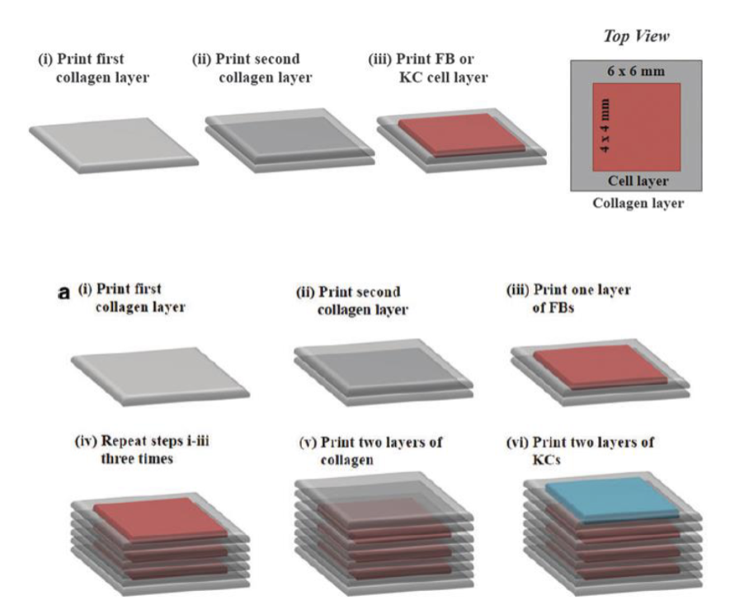
Skin Bio-Printing - Process and Visualization

1. Bio-Printing Process (Step-by-Step)
- Layer-by-Layer Construction (逐層構建):
- (i) Print the first collagen layer (第一層膠原層).
- (ii) Print the second collagen layer (第二層膠原層).
- (iii) Add a layer of FBs (fibroblasts, 成纖維細胞) or KCs (keratinocytes, 角質細胞).
- (iv) Repeat steps (i)–(iii) three times to form a multilayer base structure (重複步驟三次，形成多層結構).
- (v) Add two additional collagen layers.
- (vi) Print two layers of KCs on top to form the epidermis (表皮).

2. Top View Representation
- Dimensions:
- Collagen layers (膠原層): Entire 6 × 6 mm area.
- Cell layers (FB or KC) (細胞層): Central 4 × 4 mm area for better spatial control (更精準的細胞位置控制).

3. Key Advantages
- Precision: Multiple types of cells and matrices are accurately located in specific layers (不同細胞和基質能被精準排列).
- Scalability: High throughput process enables larger structures (高通量工藝可製作大面積結構).
- Reproducibility: Tailored, hierarchical structures ensure consistent results (層次化結構提高可重現性).

4. Final Product Visualization
- After 7 days of culture:
- Epidermis: Compact, stratified layers of KCs (緊密分層的角質細胞).
- Dermis: Fibroblasts are elongated and distributed uniformly (拉長且均勻分佈的成纖維細胞).
- Visualized using confocal microscopy (共聚焦顯微鏡).
P. 24
Laser Bio-Printing (LaBP) (Shortened)
1. Technology
- Laser-assisted BioPrinting (LaBP) (雷射輔助生物列印): Uses laser-induced forward transfer (雷射誘導向前轉移) to arrange cells in 3D structures.
2. Key Features
- Positions very small volumes (down to femtoliters, 飛升升量級).
- High resolution and cell densities (up to \(10^8\) cells/mL).
- Hydrogel precursors (水凝膠前驅物) of any viscosity can be used.
- Cells remain unharmed during printing.
3. Applications
- Mimics natural tissue by ensuring proper cell density (細胞密度) and distribution.
- Produces 3D cell models for future tissue substitutes.
4. Study Details
- Fibroblasts (murine NIH-3T3, 小鼠成纖維細胞) and keratinocytes (human HaCaT, 人類角質細胞) were printed in collagen (膠原) layer-by-layer for skin tissue.
- Generated micropatterned layers (微圖案化層).
5. Visualization
- Top: Grid structure (網格結構) of fibroblasts (green, 綠色) and keratinocytes (red, 紅色).
- Bottom: Seven alternating layers (七層交替).
- Structure: Height ~2 mm, Base: 10 × 10 mm.
- Scale bar: 500 µm.

P. 29
In Situ Bioprinting for Skin Regeneration (Shortened)
1. Type of Bioprinting Technology
- In Situ Bioprinting (原位生物列印): Printing directly at the wound site to deliver AFS cells (amniotic fluid-derived stem cells, 羊水來源幹細胞) embedded in a fibrin-collagen hydrogel (纖維蛋白-膠原水凝膠).
2. Key Features
- Uses pressure-driven, computer-controlled bioprinting device (壓力驅動且電腦控制的生物列印裝置).
- Components include thrombin (凝血酶) for gel crosslinking and fluorescent labeling (螢光標記) for cell visualization.
3. Advantages
- Promotes wound healing by evenly distributing cells directly to the wound.
- Effective for large wound repair (大傷口修復), with potential for clinical applications.

Lec 14
P. 2 Blood:
1. Functions of Blood
- Delivers nutrients (養分) and oxygen (氧氣) to cells.
- Transports metabolic waste products (代謝廢物) away from tissues.
2. Components of Blood
- Platelets (血小板):
- Initiate blood clotting (凝血作用).
- No nucleus, are fragments of cells (細胞碎片).
- Red Blood Cells (Erythrocytes, 紅血球):
- Small, disc-shaped cells (小型圓盤狀細胞).
- Primary role: Deliver oxygen to tissues (運送氧氣).
- White Blood Cells (Leukocytes, 白血球):
- Immune system cells (免疫細胞).
- Defend against foreign invaders (外來入侵者) and pathogens (病原體).
- Plasma (血漿):
- Fluid containing proteins (蛋白質), glucose (葡萄糖), mineral ions (礦物質離子), hormones (荷爾蒙), carbon dioxide (二氧化碳), and blood cells.
3. Visualization
- Top image: Blood composition in a blood vessel (血管內的血液組成).
- Bottom image: Blood flow in a tadpole tail (蝌蚪尾巴內的血液流動).

P3: Hemostasis (止血)
- Definition:
- The physiological process of stopping bleeding, involving:
1. Vasoconstriction (血管收縮): Narrows blood vessels.
2. Platelet Plug Formation (血小板栓塞形成): Platelets aggregate to form a temporary seal.
3. Coagulation (凝血): Fibrin stabilizes the platelet plug.

- The process concludes with the dissolution of the clot after tissue repair.

P4: Blood Clotting
- Coagulation (凝血):
- Blood transforms from a liquid to a gel to prevent blood loss.
- Involves:
1. Platelet activation (活化).
2. Platelet adhesion (附著) to exposed collagen.
3. Deposition and maturation of fibrin (纖維蛋白) to stabilize the clot.

Key Terms:
- Fibrinogen (纖維蛋白原): A plasma protein converted into fibrin.
- Platelet Plug (血小板栓): A temporary blockage at the injury site.

P6: Thrombosis (血栓形成)
- Definition: Formation of a blood clot (thrombus) within a vessel, which can block blood flow.
- Causes:
- Vessel wall injury.
- Stagnant blood flow.
- Hypercoagulability (高凝血性).

Complications:
1. Thrombophlebitis (血栓靜脈炎): Inflammation of veins with clots.
2. Embolization (栓塞): Movement of a clot to another location, potentially causing blockage.

P7: Catheters (導管)
- Central Venous Catheter (CVC):
- A tube inserted into large veins (neck, chest, or groin).
- Used for fluid delivery, blood sampling, or administering medications.

Materials:
- Common polymers include:
1. Silicone (矽膠).
2. Polyurethane (聚氨酯).
3. Polyethylene terephthalate (PET) (聚對苯二甲酸乙二酯).

P8-9: Blood Transfer Outside the Body
Processes:
1. Dialysis (透析):
- Removes waste and excess water from blood, mimicking kidney function.
- Types:
- Hemodialysis (血液透析): Blood is filtered outside the body using a dialyzer.
- Peritoneal dialysis (腹膜透析): Utilizes the peritoneum as a natural filter.

2. ECMO (體外膜氧合):
- Supports heart and lung functions by oxygenating blood externally.
- Types:
- VA ECMO: Oxygenated blood is returned to the arteries.
- VV ECMO: Oxygenated blood is returned to the veins.

P10: Artificial Spleen
- Purpose: Filters bacteria from the bloodstream to prevent sepsis (敗血症).
- Uses magnetic bead-based microfluidics (磁珠微流體技術) to remove pathogens like bacteria and viruses.

Sepsis Progression:
1. Early Sepsis: Immune response triggers inflammation.
2. Septic Shock (感染性休克): Severe low blood pressure leads to organ failure.

P16: Coagulation Cascade (凝血級聯反應)
- A series of chemical reactions involving clotting factors (凝血因子) and proteins.
- Result: Formation of cross-linked fibrin to stabilize clots.
- Pathways:
1. Intrinsic Pathway (內源性途徑): Triggered by blood contact with foreign surfaces.
2. Extrinsic Pathway (外源性途徑): Triggered by tissue injury.

P19: Blood Clotting with Catheters
- Problem: Catheters can trigger thrombus formation on their surfaces.
- Consequences: Blocked blood flow, infections, or embolisms.

P26: Anticoagulants (抗凝劑)
- Drugs that prevent or reduce blood clotting.
- Examples:
1. Heparin (肝素): A naturally occurring anticoagulant.
2. Warfarin (華法林): Used to prevent clots in high-risk patients.

Applications:
- Medical devices (e.g., test tubes, dialysis machines) are coated with anticoagulants to prevent clots.

P28-29: Material Requirements for Catheters
1. Biological Properties:
- Non-toxic.
- Low tendency for biofilm (生物膜) formation.
- Non-thrombogenic (低血栓傾向).

2. Physical Properties:
- High tensile strength.
- Flexible and durable.
- Radiopaque (能被X光檢測).

3. Chemical Properties:
- Stable during storage and sterilization.
- Supports surface coatings (表面塗層) like hydrogels or antibacterial agents.

P30-31: Polymers to Reduce Clotting
- Approaches:
1. Physical Modification: Adjust surface wettability (潤濕性) or texture.
2. Chemical Modification: Add hydrophilic coatings, like PEG (聚乙二醇).
3. Biological Modification: Promote endothelialization (內皮化).

P46: Blood Vessel Structure
- Artery Layers:
1. Tunica intima (內膜): Endothelium layer.
2. Tunica media (中膜): Muscle layer with elastin and collagen.
3. Tunica externa (外膜): Connective tissue for structural support.
Artery Types:
- Elastic Arteries: Near the heart; high elastin content.
- Muscular Arteries: Supply specific tissues; more smooth muscle.

P48-49: Angioplasty (血管成形術)
- Process: A balloon catheter widens narrowed arteries.
- Stent (支架): Inserted to keep vessels open.

Complications:
1. Restenosis (再狹窄): Narrowing of the artery after treatment.
2. Neointimal Hyperplasia (新內膜增生): Overgrowth of tissue inside the stent.

P50-56: Stents (支架)
- Types:
1. Bare-metal stents (金屬支架).
2. Drug-eluting stents (藥物洗脫支架): Release antiproliferative drugs.
3. Biodegradable stents (可降解支架).

Materials:
- Common: Cobalt-chromium alloy (鈷鉻合金), Nitinol (鎳鈦合金).

P64-68: Vascular Grafts (血管移植物)
- Replace or repair damaged vessels.

Synthetic Materials:
1. PET (聚酯): Non-degradable

, used for large vessels.
2. ePTFE (聚四氟乙烯): Inert, durable, reduces thrombosis risk.
Challenges:
- Achieving tissue integration and preventing thrombosis.

